**Integrated Clinical Guideline: Recurrent Pregnancy Loss (RPL)**

*Synthesized from ASRM (2023), RCOG Green‑top No. 17 (2023), ESHRE (2017, updates ongoing), and ACOG (2020)*

**1) Scope & Purpose**

* Target users: Obstetricians/gynecologists, fertility specialists, early pregnancy units, and primary care clinicians.
* Population: Couples with recurrent pregnancy loss (RPL).
* Settings: Preconception, early pregnancy care, outpatient and inpatient gynecology.

**2) Definitions**

* Clinical pregnancy: ultrasonographic evidence of an intrauterine gestational sac or histopathological confirmation.
* Recurrent Pregnancy Loss (RPL):

• ASRM/ESHRE/ACOG: ≥2 clinical pregnancy losses (not necessarily consecutive).

• RCOG: ≥3 consecutive clinical miscarriages (may offer evaluation after 2, especially with maternal age ≥35, prior fetal cardiac activity, or late loss).

* Exclude: ectopic and molar pregnancies from the RPL count (manage separately).
* Classify by gestation: early (<10 weeks), late (10–20 weeks); and by etiology (explained vs unexplained).

**3) Epidemiology & Prognosis**

* Miscarriage occurs in ~15–20% of clinically recognized pregnancies; RPL affects ~1–2% of couples.
* Prognosis: 60–80% will ultimately achieve a live birth even without specific therapy (after evaluation and supportive care).

**4)** **Risk Factors For Recurrent Miscarriage**

**4.1.** In more than half of women with repeated miscarriages, no cause can be found

**4.2. Epidemiological factors**

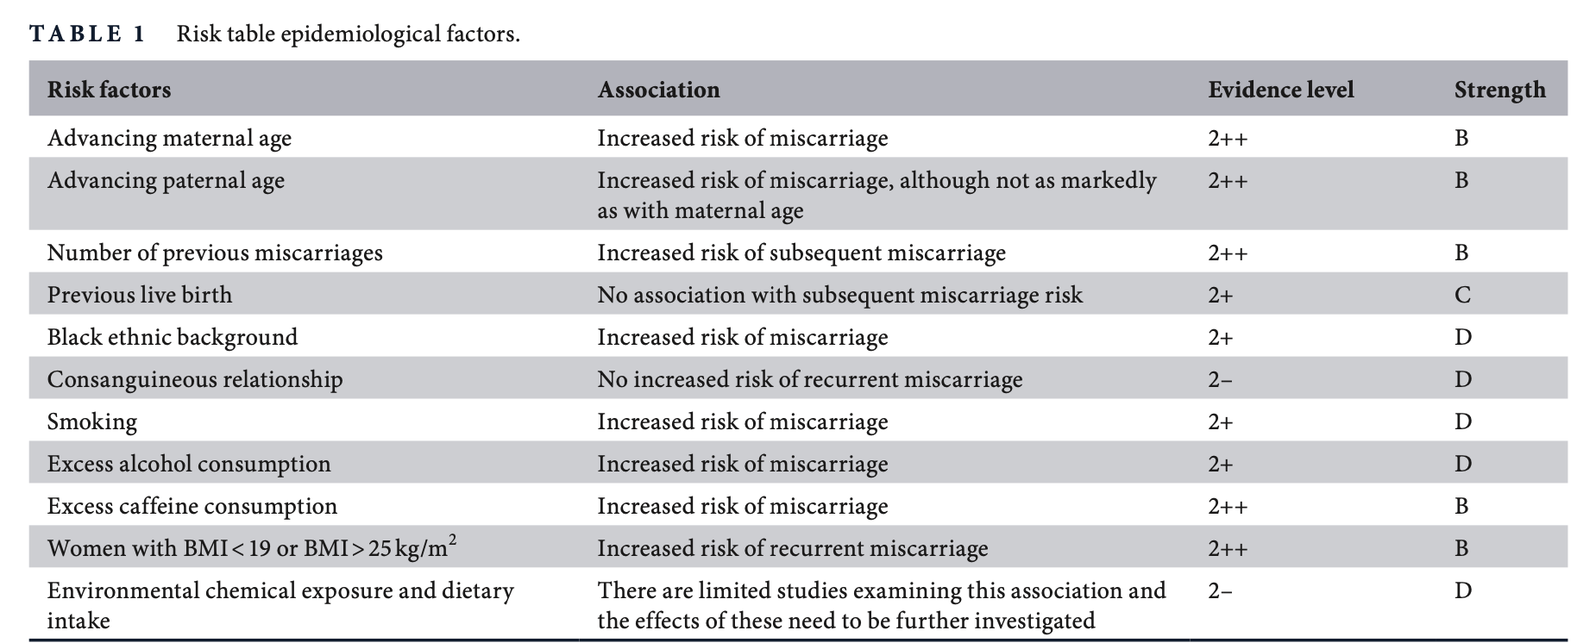

**4.3. Thrombophilia**

**4.3.1. Acquired:** Antiphospholipid syndrome (APS) is defined as the asso- ciation between antiphospholipid (aPL) antibodies (lupus anticoagulant, anticardiolipin [aCL] antibodies and anti- beta-2-glycoprotein-I antibodies) and adverse pregnancy outcome or vascular thrombosis.

Adverse pregnancy outcomes include:

**•** three or more consecutive miscarriages before 10 weeks of gestation;

**•** one or more morphologically normal fetal losses after the tenth week of gestation

**•** one or more preterm births before 34+0 weeks of gestation because of placental disease.

**4.3.2. Inherited:** Inherited thrombophilias, including Factor V Leiden muta- tion, protein C and S deficiencies, antithrombin deficiency and prothrombin gene mutation.

**4.4. Genetic factors**

4.3.1.Parental chromosomal rearrangements : Balanced Translocations

4.3.2. Fetal chromosomal anomalies : aneuploidy

**4.5. Anatomical factors**

**4.5.1. Congenital uterine anomalies** : septate, bicornuate, arcuate (2nd trimester)

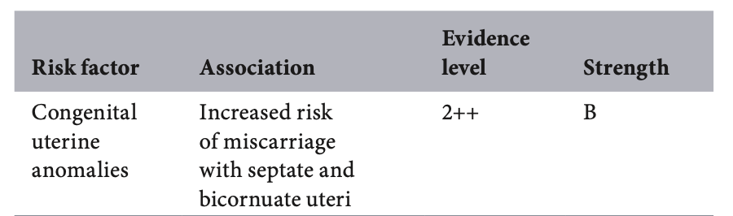

**4.5.2. Acquired uterine anomalies** : Myomas, Endometrial polyps, Intrauterine adhesions

* Identified as a risk factors by ACOG
* According to RCOG :

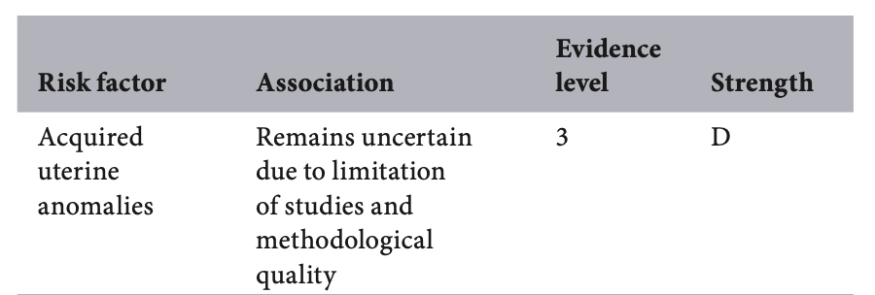

**4.5.3. Cervical integrity**

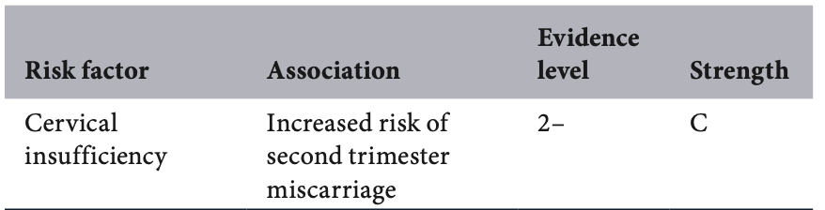

**4.6. Endocrine**

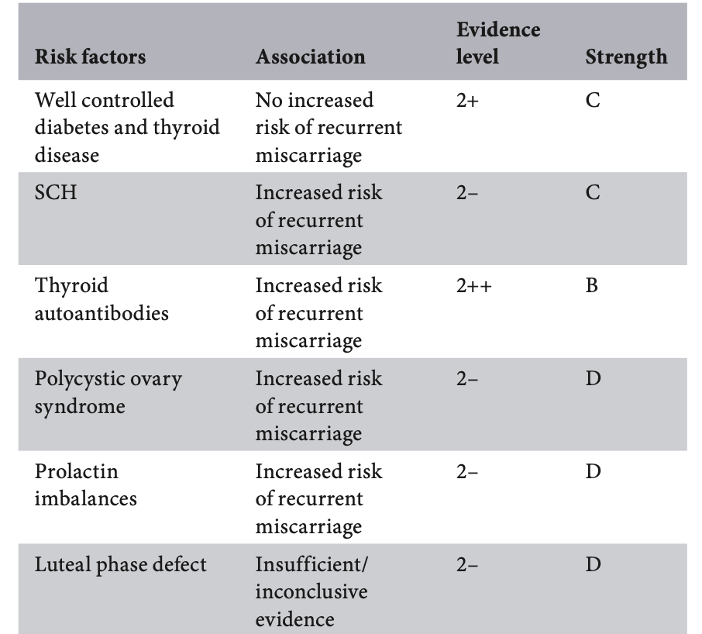

SCH: Subclinical Hypothyroidism

**4.7. Immune factors**

**4.7.1. Peripheral :** HLA, Cytokines, Peripheral natural killer cells

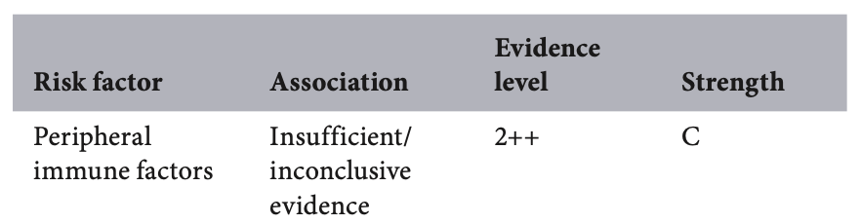

**4.7.2. Uterine** : Uterine natural killer cells

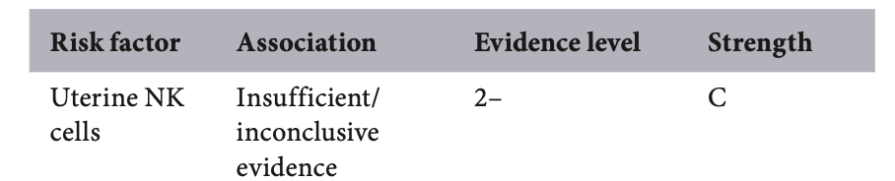

**4.8. Infective factors**

* TORCH - Not recommended
* Bacterial Vaginosis – increase second trimester miscarriages
* Chronic endometritis – has been implicated in recurrent miscarriage, although the diagnostic criteria remain controversial. Future molecular studies on the microbiome of the uterine cavity will hopefully shed more light into the role of infec- tions in recurrent miscarriage

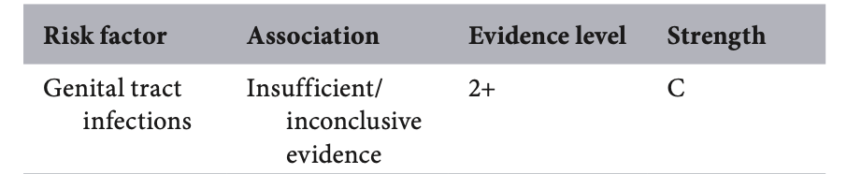

**4.9. Male factors**

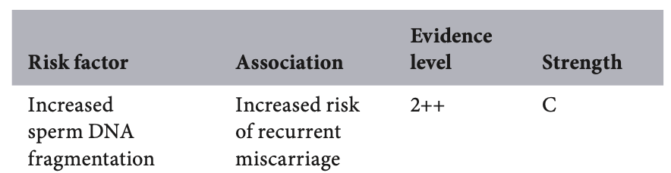

**5)** **Recommended Investigations**

**5.1. Thrombophilias**

**Acquired:**

* Test lupus anticoagulant (LA), anticardiolipin IgG/IgM, and anti‑β2‑glycoprotein I IgG/IgM.
* If any test is positive, repeat the same assay ≥12 weeks later for confirmation.
* Apply clinical + laboratory criteria to diagnose APS (obstetric morbidity and/or thrombosis plus persistent antibodies).

**Inherited:**

* Women with second trimester miscarriagemay be offered testing for Factor V Leiden, prothrombin  
  gene mutation and protein S deficiency, ideally within a research context. They should be made aware that there is currently limited evidence that treatment changes reproductive outcomes.

**5.2. Genetic**

* Cytogenetic analysis should be offered on pregnancy tissue of the third and subsequent miscarriage(s) and in any second trimester miscarriage- chromosomal microarray preferred.
* Parental peripheral blood karyotyping should be performed for couples in whom testing of pregnancy tissue reports an unbalanced structural chromosomal abnormality. The finding ofa subsequent abnormal parental karyotype should prompt referral to a clinical geneticist.
* When cytogenetic analysis is indicated but testing of the pregnancy tissue is unsuccessful or there is no pregnancy tissue available for testing, parental karyotyping should be offered.

**5.3. Uterine Anatomy**

* Methods of evaluation: 3D USG, saline infusion sonohysterography, hysterosalpingography (HSG), or diagnostic hysteroscopy.
* First‑line imaging: 3D ultrasound
* MRI and endoscopic evaluation for complex anomalies when a diagnosis cannot be reached with 3D ultrasound.

**5.4. Endocrine & Metabolic**

* Thyroid function: TSH (aim <2.5 mIU/L preconception/1st trimester); treat overt hypo/hyperthyroidism.
* Glycemic status: HbA1c and/or fasting glucose; optimize preconception if abnormal.
* Prolactin: consider if cycle disturbance/galactorrhea; treat confirmed hyperprolactinemia.
* PCOS/obesity: address weight, metabolic syndrome; lifestyle and comorbidity management.

**5.5. Immune**

* Women with recurrent miscarriage should not be routinely offered immunological screening (such as HLA, cytokine and NK cell tests), outside of a research context.

**5.6. Infective**

* Women with recurrent miscarriage should not be routinely offered infection screening outside of the research context.

**5.7. Male factors**

* Couples with recurrent miscarriage should not be routinely offered sperm DNA testing outside of the research context.

**5.8. Tests Not Routinely Recommended**

* Inherited thrombophilia panels (e.g., Factor V Leiden, prothrombin mutation, protein C/S/antithrombin) in the absence of personal/strong family history of venous thromboembolism.
* Infectious work‑ups (TORCH, chronic endometritis) without specific clinical indications.
* Immune assays such as NK cell number/function tests, HLA compatibility, or alloimmune tests; IVIG, intralipids, steroids outside APS are not supported.

**6)** **Evidence-Based Management**

**6.1. Lifestyle modifications:**

* Women with recurrent miscarriage should be advised to maintain a BMI between 19 kg/m2 and 25 kg/m2, smoking cessation, limit alcohol consumption and limit caffeine to less than 200mg/day.

**6.2. Thrombophilias:**

**6.2.1. Acquired**

* Aspirin and heparin (unfractionated heparin [UFH] or LMWH) should be offered to women with APS (e.g. 75 mg aspirin orally and 40 mg subcutaneously enoxaparin from a positive pregnancy test until at least 34 weeks of gestation). Clinicians and women should be aware that treatment with heparin, particularly UFH, is not without some risk**.**
* Aspirin and/or heparin should not be given to women with unexplined recurrent miscarriage.

**6.2.2. Inherited**

* There is a lack of evidence to support routine treatment for women with Factor V Leiden, protein S deficiency and prothrombin gene mutation to reduce the incidence of recurrent miscarriage or second trimester loss.
* A decision to treat women with recurrent miscarriage or second trimester loss can be individualized and should involve a discussion with the woman, taking into consideration additional risk factors, such as maternal risk of thrombosis.

**6.3. Genetic factors:**

* Options for couples with chromosomal rearrangements include attempting a further natural conception, PGT-SR or gamete donation**.**
* There are currently insufficient data to support the routine use of PGT-A for couples with unexplained recurrent miscarriage, while the treatment may carry significant cost and potential risk.

**6.4. Anatomical factors:**

**6.4.1. Congenital uterine anomalies**

* Resection of a uterine septum should be considered for women with recurrent first or second trimester miscarriage, ideally within an appropriate audit or research context.

**6.4.2. Acquired uterine anomalies**

* There is a lack of evidence to guide the management of acquired uterine anomalies associated with recurrent miscarriage; counselling and the choice of expectant versus surgical options ought to be individualised**.**

**6.4.3. Cervical integrity (NICE: Preterm labour and birth)**

* Offer a choice of prophylactic vaginal progesterone or prophylactic cervical cerclage to women who have both: • a history of spontaneous preterm birth (up to 34+0 weeks of pregnancy) or loss (from 16+0 weeks of pregnancy onwards), and • results from a transvaginal ultrasound scan carried out between 16+0 and 24+0 weeks of pregnancy that show a cervical length of 25 mm or less. Discuss the risks and benefits of both options with the woman, and make a shared decision on which treatment is most suitable.
* Consider prophylactic vaginal progesterone for women who have either: • a history of spontaneous preterm birth (up to 34+0 weeks of pregnancy) or loss (from 16+0 weeks of pregnancy onwards), or • results from a transvaginal ultrasound scan carried out between 16+0 and 24+0 weeks of pregnancy that show a cervical length of 25 mm or less. In April 2024, the only licensed preparation of progesterone for this indication was vaginal 200 mg capsules. When using vaginal progesterone, start treatment between 16+0 and 24+0 weeks of pregnancy and continue until at least 34 weeks. [2019]
* Consider prophylactic cervical cerclage for women when results of a transvaginal ultrasound scan carried out between 16+0 and 24+0 weeks of pregnancy show a cervical length of 25 mm or less, who have had either: • preterm prelabour rupture of membranes (P-PROM) in a previous pregnancy or • a history of cervical trauma.
* If prophylactic cervical cerclage is used, ensure a plan is made and documented for removal of the suture.

**6.5. Endocrine factors:**

* Thyroxine supplementation is not routinely recommended for euthyroid women with TPO who have a history of miscarriage.
* Thyroxine supplementation may be considered for women with moderate SCH (TSH 4 mIU/l) but is not routinely recommended for women with mild SCH (TSH more than 2.5 mIU/L) irrespective of TPO status.
* Regular TSH measurement from 7–9 weeks of gestation is recommended in cases with TPO and/or SCH
* Progestogen supplementation should be considered in women with recurrent miscarriage who present with bleeding in early pregnancy (for example 400 mg micronised vaginal progesterone twice daily at the time of bleeding until 16 weeks of gestation).
* Routine supplementation should be used with caution in asymptomatic women with unexplained recurrent miscarriage.

**6.6. Immune factors:**

* Immunotherapy (e.g. paternal cell immunisation, third-party donor leucocytes, trophoblast membranes and intravenous immunoglobulin [IVIg]) is not recommended for women with recurrent miscarriage.

**6.7. Male factors:**

* There is no evidence to recommend treatments for male factors.

**6.8. Unexplained recurrent miscarriage:**

* Women with unexplained recurrent miscarriage should be offered supportive care, ideally in the setting of a dedicated recurrent miscarriage clinic.
* Endometrial scratch is not recommended in women with recurrent miscarriage.

**6.9. Adjuncts & What Not to Use**

* Avoid routine use of steroids, IVIG, intralipids, G‑CSF, aspirin alone (without APS), or anticoagulation for inherited thrombophilia in the absence of APS.
* Metformin is not an RPL treatment per se; use for glycemic/PCOS indications only.

**7) Preconception & Lifestyle Optimization**

* Folic acid: ≥400 μg daily (consider 4–5 mg with diabetes or prior NTD as per local policy).
* Weight management: aim BMI 19–25; offer diet/exercise programs; manage sleep and stress.
* Smoking cessation, avoid alcohol and recreational drugs; limit caffeine (<200 mg/day).
* Review and rationalize medications; avoid teratogens; ensure vaccinations are up to date (e.g., rubella, varicella status).

**8) Care Pathway & Follow‑up**

* Offer evaluation after 2 losses (earlier if age ≥35 or late miscarriage).
* Provide written plan for next pregnancy: whom to contact at positive test, when to start LDA/LMWH (if indicated), progesterone regimen (if chosen), and early scan scheduling.
* Early Pregnancy Unit access for reassurance scans and symptom triage.
* Psychological support: counseling/referral; screen for anxiety/depression; bereavement services after loss.
* Document discussion of prognosis and safety‑net advice (bleeding/pain, ectopic warning).

**9) Special Situations**

* Second‑trimester loss or recurrent late loss: evaluate for cervical insufficiency, fetal/placental pathology, maternal systemic disease; consider cerclage based on history and cervical length.
* Assisted reproduction: align luteal support with ART protocol; consider PGT where indicated (structural rearrangements, translocations).
* Secondary RPL after prior live birth: similar evaluation; emphasize age‑related aneuploidy with advancing maternal age.

**10) Documentation & Communication**

* Summarize prior pregnancies with dates, gestation, ultrasound findings, and pathology/genetics.
* Include all tests performed, results, and interpretations; record patient preferences and shared decisions.
* Provide a concise, patient‑held plan for the next conception attempt.

**11) Quality Indicators (Audit)**

* Proportion of eligible couples receiving APS panel and uterine imaging.
* Time from referral to completion of core work‑up (target ≤8–12 weeks).
* Documentation of counseling and a written plan for next pregnancy.
* Live‑birth rate within 12–24 months of completing evaluation.

**12) Medication Dosing Summary (Quick Reference)**

* Low‑dose aspirin: 75–100 mg orally once daily (evening dosing acceptable).
* LMWH prophylactic: enoxaparin 40 mg SC daily (or equivalent); start at positive test for APS; continue through pregnancy.
* LMWH therapeutic (prior thrombosis/high‑risk APS): enoxaparin 1 mg/kg SC twice daily.
* Progesterone: micronized vaginal 200–400 mg/day or dydrogesterone 10 mg twice daily to 12–16 weeks.
* Levothyroxine dosing per TSH; recheck every 4–6 weeks in 1st/2nd trimester.

**13) Patient Information (for counseling leaflets)**

* Most couples will conceive and carry a healthy pregnancy in the future.
* A stepwise evaluation looks for a small set of causes that have proven treatments.
* Healthy lifestyle, early contact on a positive test, and supportive care improve the journey.

**References & Source Guidelines**

* ASRM Committee Opinion on Evaluation and Treatment of Recurrent Pregnancy Loss (2023).
* RCOG Green‑top Guideline No. 17: Recurrent Miscarriage (2023).
* ESHRE Guideline on Recurrent Pregnancy Loss (2017; updates ongoing).
* ACOG Practice Bulletin: Early Pregnancy Loss/Management considerations (2020).